Mixing Nozzle Enquiry – Extrusion

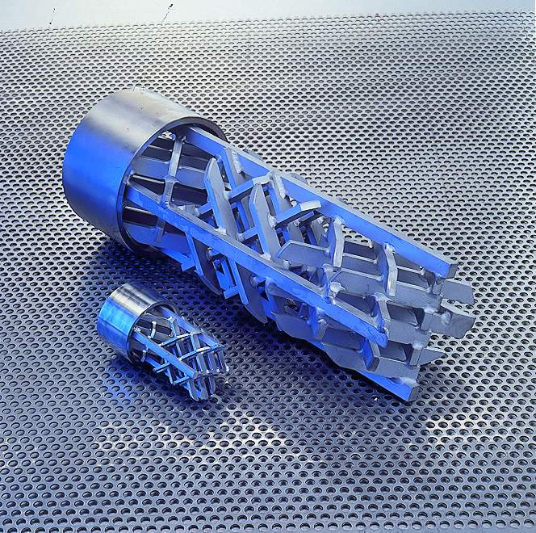

IMPROVEMENT
 | Eliminate Thermal Inhomogeneity
Eliminate Color Problems
Color: MB liquid color powder
 | Improved regrind usage
 | Other:
POLYMER INFORMATION
Material:
Manufacturer:
MFI (g/10Min): at °C kp
Viscosity (Flow curve), attached: yes /no
MELT BLENDER HOUSING
Housing required: yes /no
Heating: yes /no
Melt pressure sensor: yes /no
Melt temperature sensor: yes /no
Breaker plate: yes /no
COMPANY INFORMATION
Company:
Name:
Department:
Street:
Zip code / City:
Phone:
Fax:
E-mail:
EXTRUSION PROCESS
 | Sheet |  | Profiles
 | Flat Film |  | Cable + Wire
 | Co- extrusion |  | Monofilaments
 | Blow- film |  | Foam
 | Pipe
PROCESS DATA
Through put: kg/h
Melt temperature: °C
System pressure: bar/psi
EXTRUSION SYSTEM DATA
Screw diameter: |  |  |  | L/D:
Extruder- Manufacturer:
Extruder- Typ:
Screen changer: yes /no |  | Gear pump: yes /no
Max. installation length: mm
Max. allowed pressure drop: bar/psi

